CCGS B &W horiz

YEAR 12

PHYSICS STAGE 3

**TRIAL EXAMINATION 2013**

|  |  |
| --- | --- |
| 1 |  |
| 2 |  |
| 3 |  |
| Total |  | / 180 = % |

**TIME**

**Solutions**

**Time allowed for this paper**

Reading time before commencing work: ten minutes

Working time for paper: three hours

**Materials required/recommended for this paper**

***To be provided by the supervisor***

This Question/Answer Booklet

Formulae and Data Booklet

***To be provided by the candidate***

Standard items: pens (blue/black preferred), pencils (including coloured), sharpener, correction fluid/tape, eraser, ruler, highlighters

Special items: non-programmable calculators approved for use in the WACE examinations, drawing templates, drawing compass and a protractor

**Important note to candidates**

No other items may be taken into the examination room. It is **your** responsibility to ensure that you do not have any unauthorised notes or other items of a non-personal nature in the examination room. If you have any un-authorised material with you, hand it to the supervisor **before** reading any further.

**Structure of this paper**

|  |  |  |  |  |  |
| --- | --- | --- | --- | --- | --- |
| Section | Number of questions available | Number of questions to be answered | Suggested working time (minutes) | Marks available | Percentage of exam |
| Section One: Short Answers | 15 | 15 | 50 | 54 | 30% |
| Section Two:  Problem-Solving | 6 | 6 | 90 | 90 | 50% |
| Section Three:  Comprehension | 2 | 2 | 40 | 36  100 | 20% |

**Total**

**Instructions to candidates**

1. Write your answers in this Question/Answer Booklet.

2. When calculating numerical answers, show your working or reasoning clearly. Give final answers to **three** significant figures and include appropriate units where applicable.

When estimating numerical answers, show your working or reasoning clearly. Give final answers to a maximum of **two** significant figures and include appropriate units where applicable.

3. You must be careful to confine your responses to the specific questions asked and to follow any instructions that are specific to a particular question.

4. The Formulae and Data booklet is **not** handed in with your Question/Answer Booklet.

YEAR 12

PHYSICS STAGE 3

**TRIAL EXAMINATION 2013**

**Section One: Short Response**

This section has **fifteen (15)** questions. Answer **all** questions. Write your answers in the space provided.

Suggested working time for this section is **50 minutes**.

**Question 1 (5 marks)**

Two identical balls (x and y) are launched simultaneously, in a horizontal direction, from the same height from a device as shown in the diagram below.

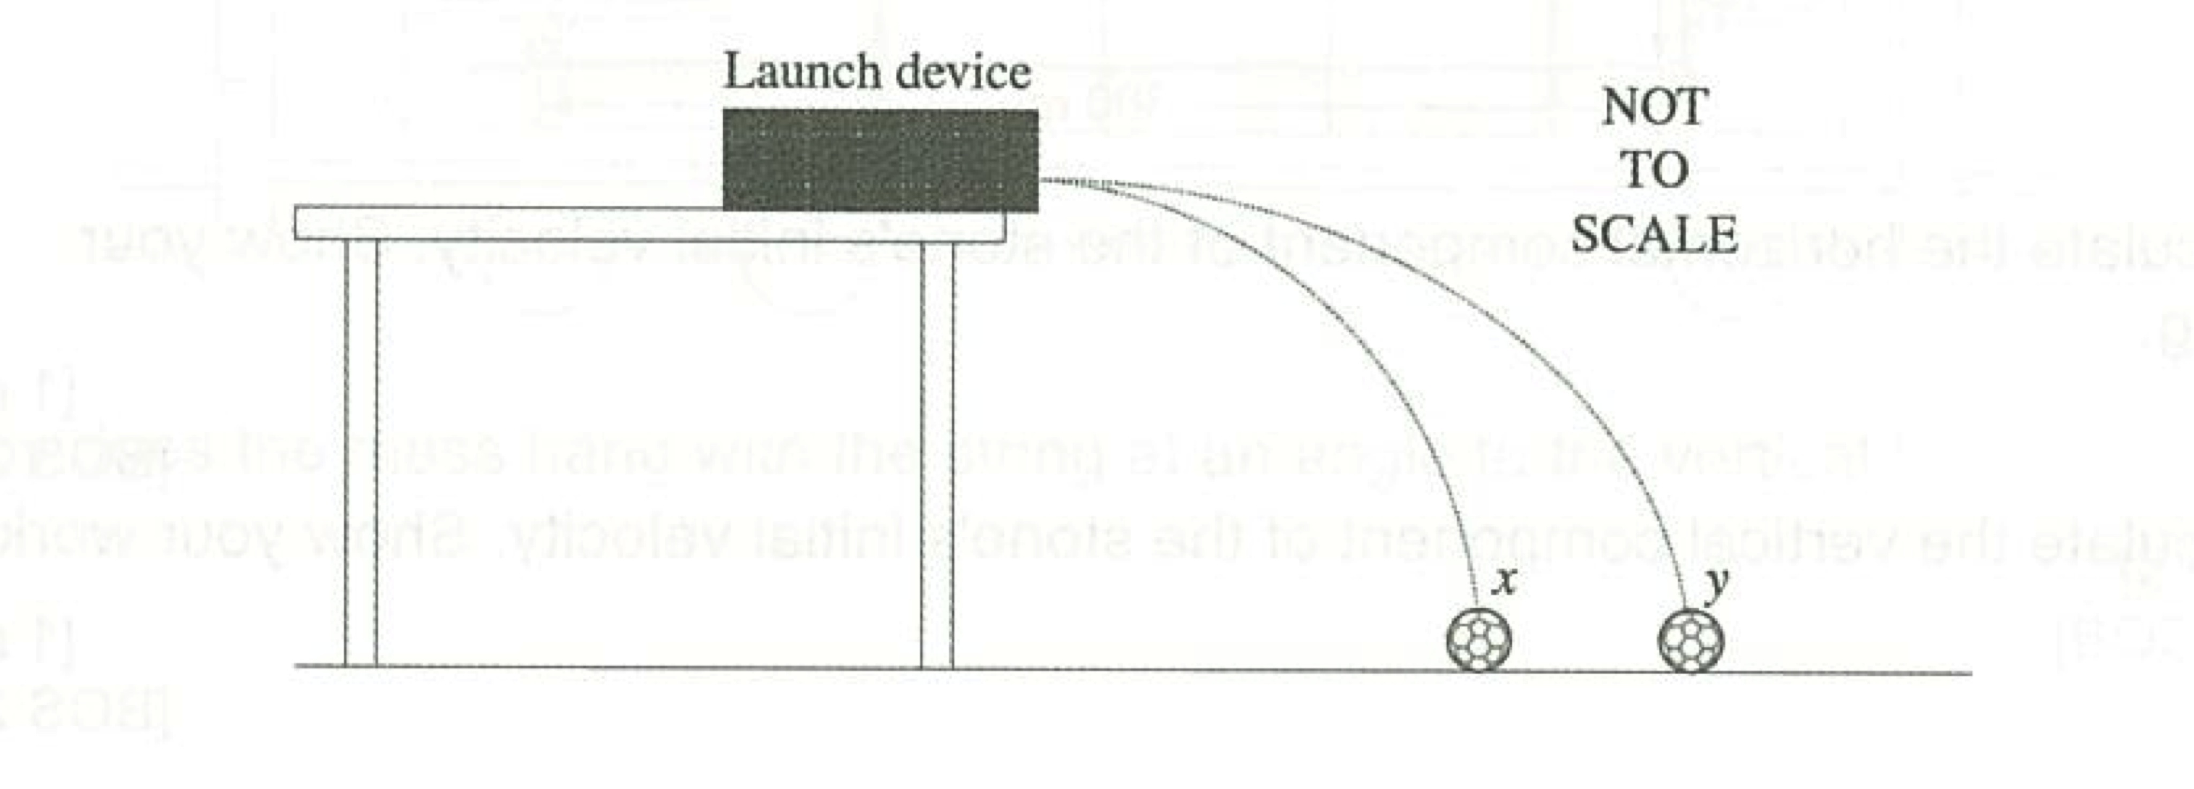

(a) Choose the statement that correctly describes this situation by circling your chosen answer below.

(1 mark)

(i) *x* lands on the ground before *y* as it is closer to the launch site.

(ii) *y* lands on the ground before *x* as it has a higher launch velocity.

(iii) *x* and *y* land on the ground simultaneously with the same velocity.

(iv) *x* and *y* land on the ground simultaneously with different velocities.

(b) Explain why you chose your answer to (a) and account for why the balls landed at different positions.

(4 marks)

* The initial vertical speed of both balls is zero and the only force both balls experience is the force due to gravity in the downwards vertical direction.
* Therefore both balls will fall towards the ground at the same rate and so will land on the ground simultaneously.
* For y to land at a greater distance from the launcher it must have had a higher initial horizontal speed.
* As the horizontal speed of each ball does not change (no force acting in the x-direction), but they both have the same vertical speed when landing, the overall velocity of each will be different ( )



**Question 2 (3 marks)**

A 10.4 kg pram that is carrying a baby of weight 49.0 N rolls on all four wheels. The front wheels are 50.0 cm from the back wheels and 90.0 cm from the handle. Assuming that the centre of mass for the baby and pram is equidistant between the front and back wheels, what is the minimummagnitude of force that a person pushing the pram must apply to tip it back to lift the front wheels?



0.5

0.5

0.5

1

0.5

**Question 3 (4 marks)**

A charge of -1.00 μC moves at a speed of 15.0 ms-1 through a 10.0 T magnetic field as shown in the diagram below. Calculate the magnitude of the force exerted on the charge and indicate the direction of the force exerted on the charge on the diagram.

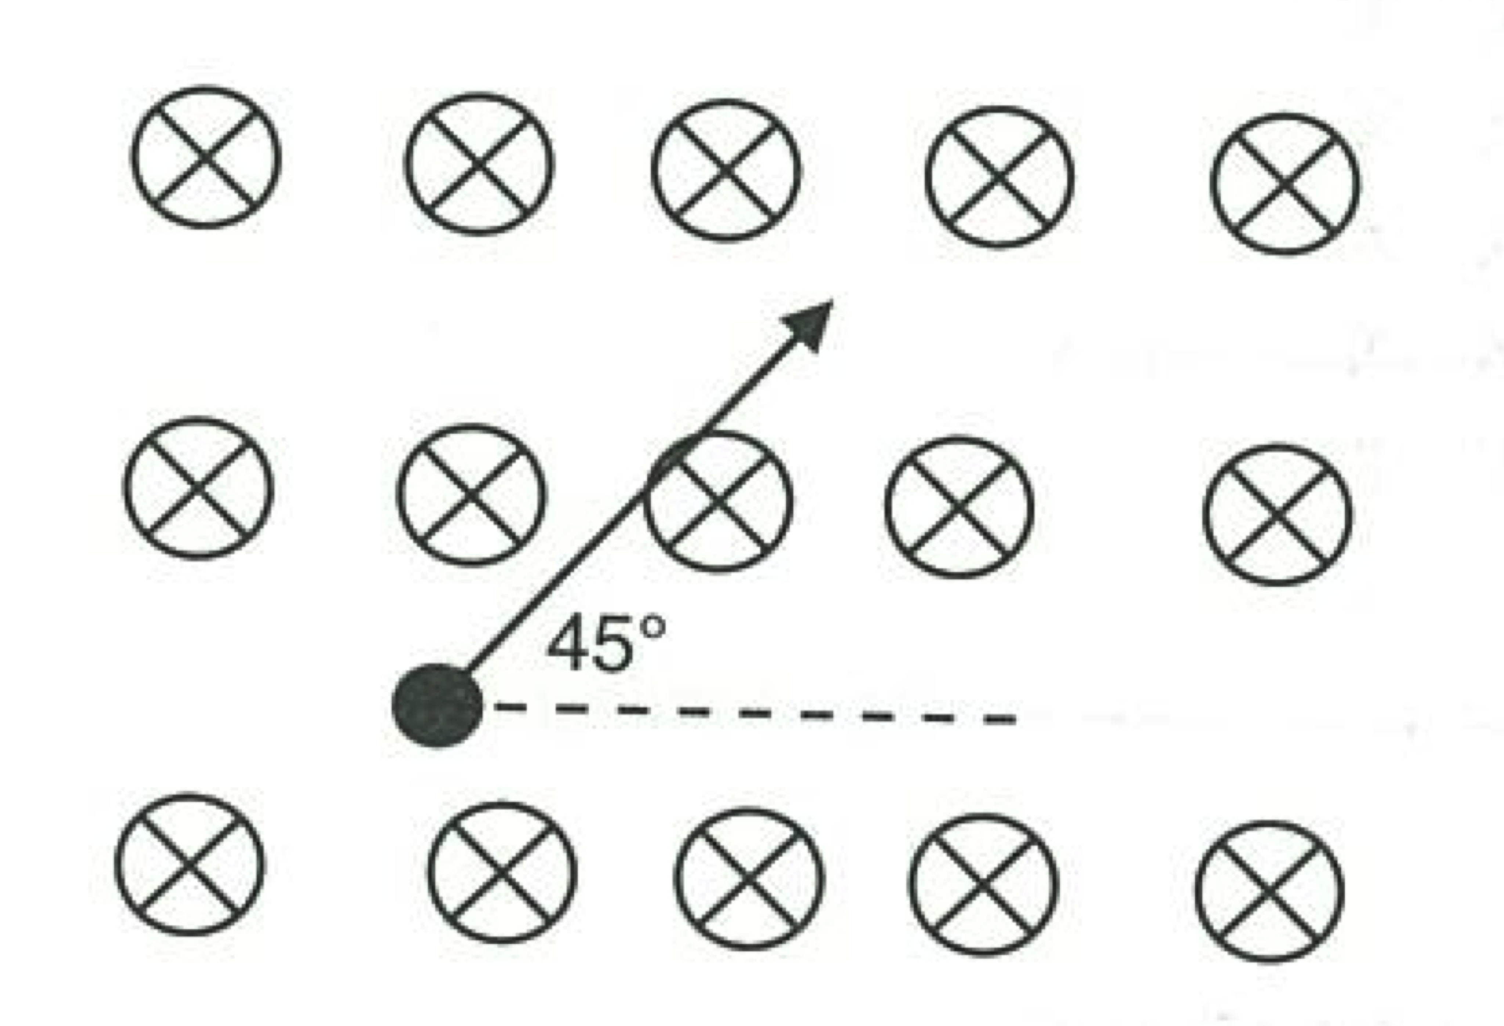

1



1

1

F

-0.5 marks if a negative out the front.

1

**Question 4 (4 marks)**

A transformer has 300 turns on its secondary and 50 turns on its primary. If the primary is connected to a 12.0 V AC source;

(a) What is the voltage output of the secondary?

(2 marks)

0.5



0.5

1

(b) If 3.00 A flows in the primary coil, how much current flows in the secondary coil?

(2 marks)

0.5



0.5

1

**Question 5 (2 marks)**

Two waves are travelling on a string. The directions and amplitude of each wave is shown in the figure below. When the two waves meet, what will be the amplitude of the resulting wave?

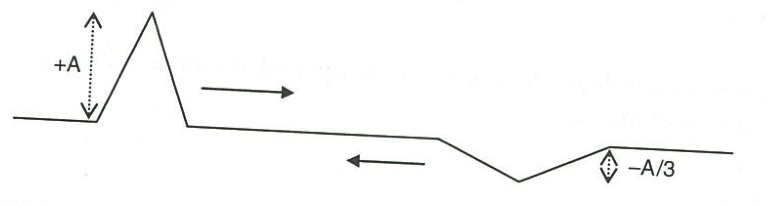

A(1-1/3) = 2A/3

1

1

**Question 6 (5 marks)**

A pendulum with a thick copper bob is swung between the poles of a strong, permanent magnet. Predict which pendulum (the solid plate or the plate with slots) will experience the greatest damping and explain your reasoning fully.

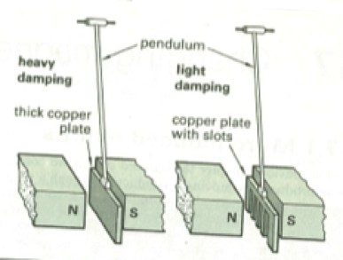

* The solid plate will experience the greatest damping.
* When the plates enter the magnetic field, the magnetic flux through the plate will increase.
* Faraday’s Law states that an emf proportional to the rate of change of magnetic flux will be induced in the plates.
* This induced emf will lead to the production of eddy currents in the plate, which according to Lenz’s Law, the direction off which will be such as to oppose the change that induced the current.
* In the copper plate with slots, there is less bulk material for the current to flow through and so the eddy currents will be less in magnitude and hence the force due to the external magnetic field acting on them will be less.

(could also discuss that the slots are not joined at the bottom).

**Question 7 (4 marks)**

Formula 1 (F1) racing cars have a wing above the rear wheels that produces a downwards force to increase traction. The wings are often made of graphite, a form of carbon that is a conductor.

wing

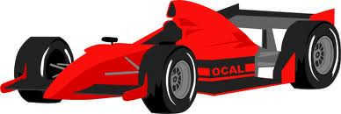

An F1 car with a 2.20 m wing is travelling southwards at 290 kmh-1 around Albert Park in Melbourne (the site of Australia’s F1 race). The Earth’s magnetic field here is 6.00 x 10-5 T at 68.0° to the horizontal.

Assuming the wing is electrically insulated from the rest of the car, determine the emf generated between the tips of the wing and state which side of the wing (relative to the driver) would be at the higher potential.

1



1

1

1

-1 if incorrect conversion to kmh-1

-0.5 if incorrect component (i.e. horizontal rather than vertical)

-1 if neither component selected (i.e. 6.00 x 10-5 used)

**Question 8 (4 marks)**

State and describe the type of spectrum that would be observed when using the setup as shown in the diagram below and explain why the incandescent lamp produces this type of spectrum.

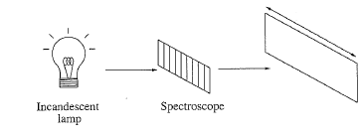

* Continuous spectrum
* Rainbow of all colours with no gaps
* Particles are moving at all different speeds and collisions mean they will undergo acceleration.
* Accelerating charged particles produce electromagnetic radiation with apparently continuous values of wavelength (producing the rainbow – in reality the wavelengths are discrete but we are not able to see this level of detail – we see a smear instead).

**Question 9 (3 marks)**

Why is the presence of the microwave background radiation that fills the universe evidence of a hot, Big Bang and an expanding universe?

* When the universe was first formed if all radiation that filled all parts of the universe was very hot, the radiation would have had very short wavelengths.
* As the universe has expanded, these wavelengths have stretched to fit the expanding space.
* Which has red-shifted the wavelengths and they are now in the microwave part of the spectrum.

**Question 10 (3 marks)**

The photons in the signal from a microwave transmitter have a wavelength of 3.50 cm. What is the energy of each photon in eV?

0.5



0.5

0.5

0.5

1

**Question 11 (2 marks)**

What will be the charge on the Lambda baryon (Λ) which has a quark configuration of ‘uds’?

+2/3 – 1/3 – 1/3 = 0

**Question 12 (5 marks)**

A child is playing on a swing as shown in the diagram below. Make any estimations required to calculate the speed of the child at the bottom of the swing’s path. Assume the girl pushing adds **no** energy to the system and the swing **does not** hit the ground at the bottom of its swing.



1

* Maximum height swing reaches = 1.2 m (+/- 0.2 m; 0.5 +/- up to 0.4; )
* Distance below where swing is at bottom of path and ground = 0.2 m (+/- 0.1 m)

1

0.5



0.5

0.5

0.5

1

**Question 13 (4 marks)**

Two observers, A on Earth and B in a spacecraft whose speed is 2.00 x 108 ms-1, both set their watches to the same time when the ship is next to Earth.

(a) To observer A, B’s watch appears to run slow, explain this observation.

(3 marks)

* Both observers must agree on the speed of light.
* B is moving away from A so the distance the light must travel is increasing.
* Therefore time will dilate to maintain the ration of space and time to give ‘c’.

(b) To B, does A’s watch seem to run fast, run slow or keep the same time as his own watch?

(1 mark)

* Run slow

**Question 14 (3 marks)**

What will be the frequency of the third overtone in a closed organ pipe if the pipe is 3.00 m long and the air temperature is 25.0°C?

1



1

1

-1 mark if n ≠ 7

**Question 15 (3 marks)**

A Ψ (psi) particle has a mass of 5.52 x 10-27 kg. Determine its rest energy in MeV.

0.5



0.5

0.5

0.5

1

**End of Section One**

YEAR 12

PHYSICS STAGE 3

**TRIAL EXAMINATION 2013**

**Section Two: Problem-Solving**

This section has **six (6)** questions. Answer **all** questions. Write your answers in the space provided.

Suggested working time for this section is **90 minutes**.

NAME:_______________________________________

**Question 1 (14 marks)**

A certain style of amusement park ride is called the ‘Pinwheel ride’. These rides work on the same basis as a sinker (heavy metal weight) twirled vertically on the end of a string.

The ride is usually made up of cars or seats that are attached to the end of long arms radiating outwards from a common centre (as shown in Figure 1).These rides are usually loaded (i.e the people get on) when horizontal and then raised to a vertical position. Because of the rigid nature of the arms, each of the cars in a pinwheel ride will travel at the same speed.

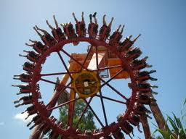

Figure 1 – An example of a pinwheel ride.

An example of one such ride is the ‘Reef Diver’ at Dreamworld (Gold Coast, Australia) as shown in Figure 2. In this ride, passengers travel in enclosed cars – the roof of the car always faces the centre of the ride – hence the passengers are not always sitting upright relative to the ground.

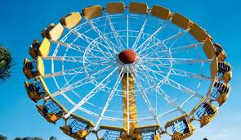

Figure 2 - The Reef Diver at Dreamworld (Gold Coast, Australia)

The Reef Diver has a diameter of 25.0 m and at one point in the ride it has a speed of 16.8 ms-1. It can be assumed that the ride is vertical (although it never truly will be) and that the average mass of a rider is 75.0 kg.

(a) Sketch a free-body diagram showing the forces on the passengers when at the bottom of the ride and calculate the magnitude of the normal force exerted on them.

(4 marks)

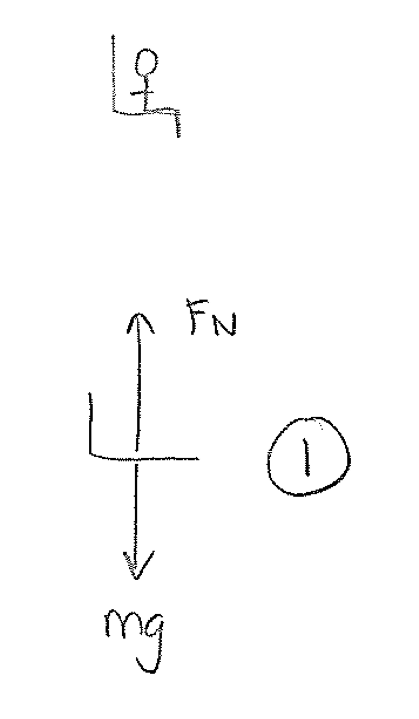



1

1

1

(b) Sketch a free-body diagram showing the forces on the passengers when at the top of the ride and calculate the magnitude of the normal force exerted on them.

(4 marks)

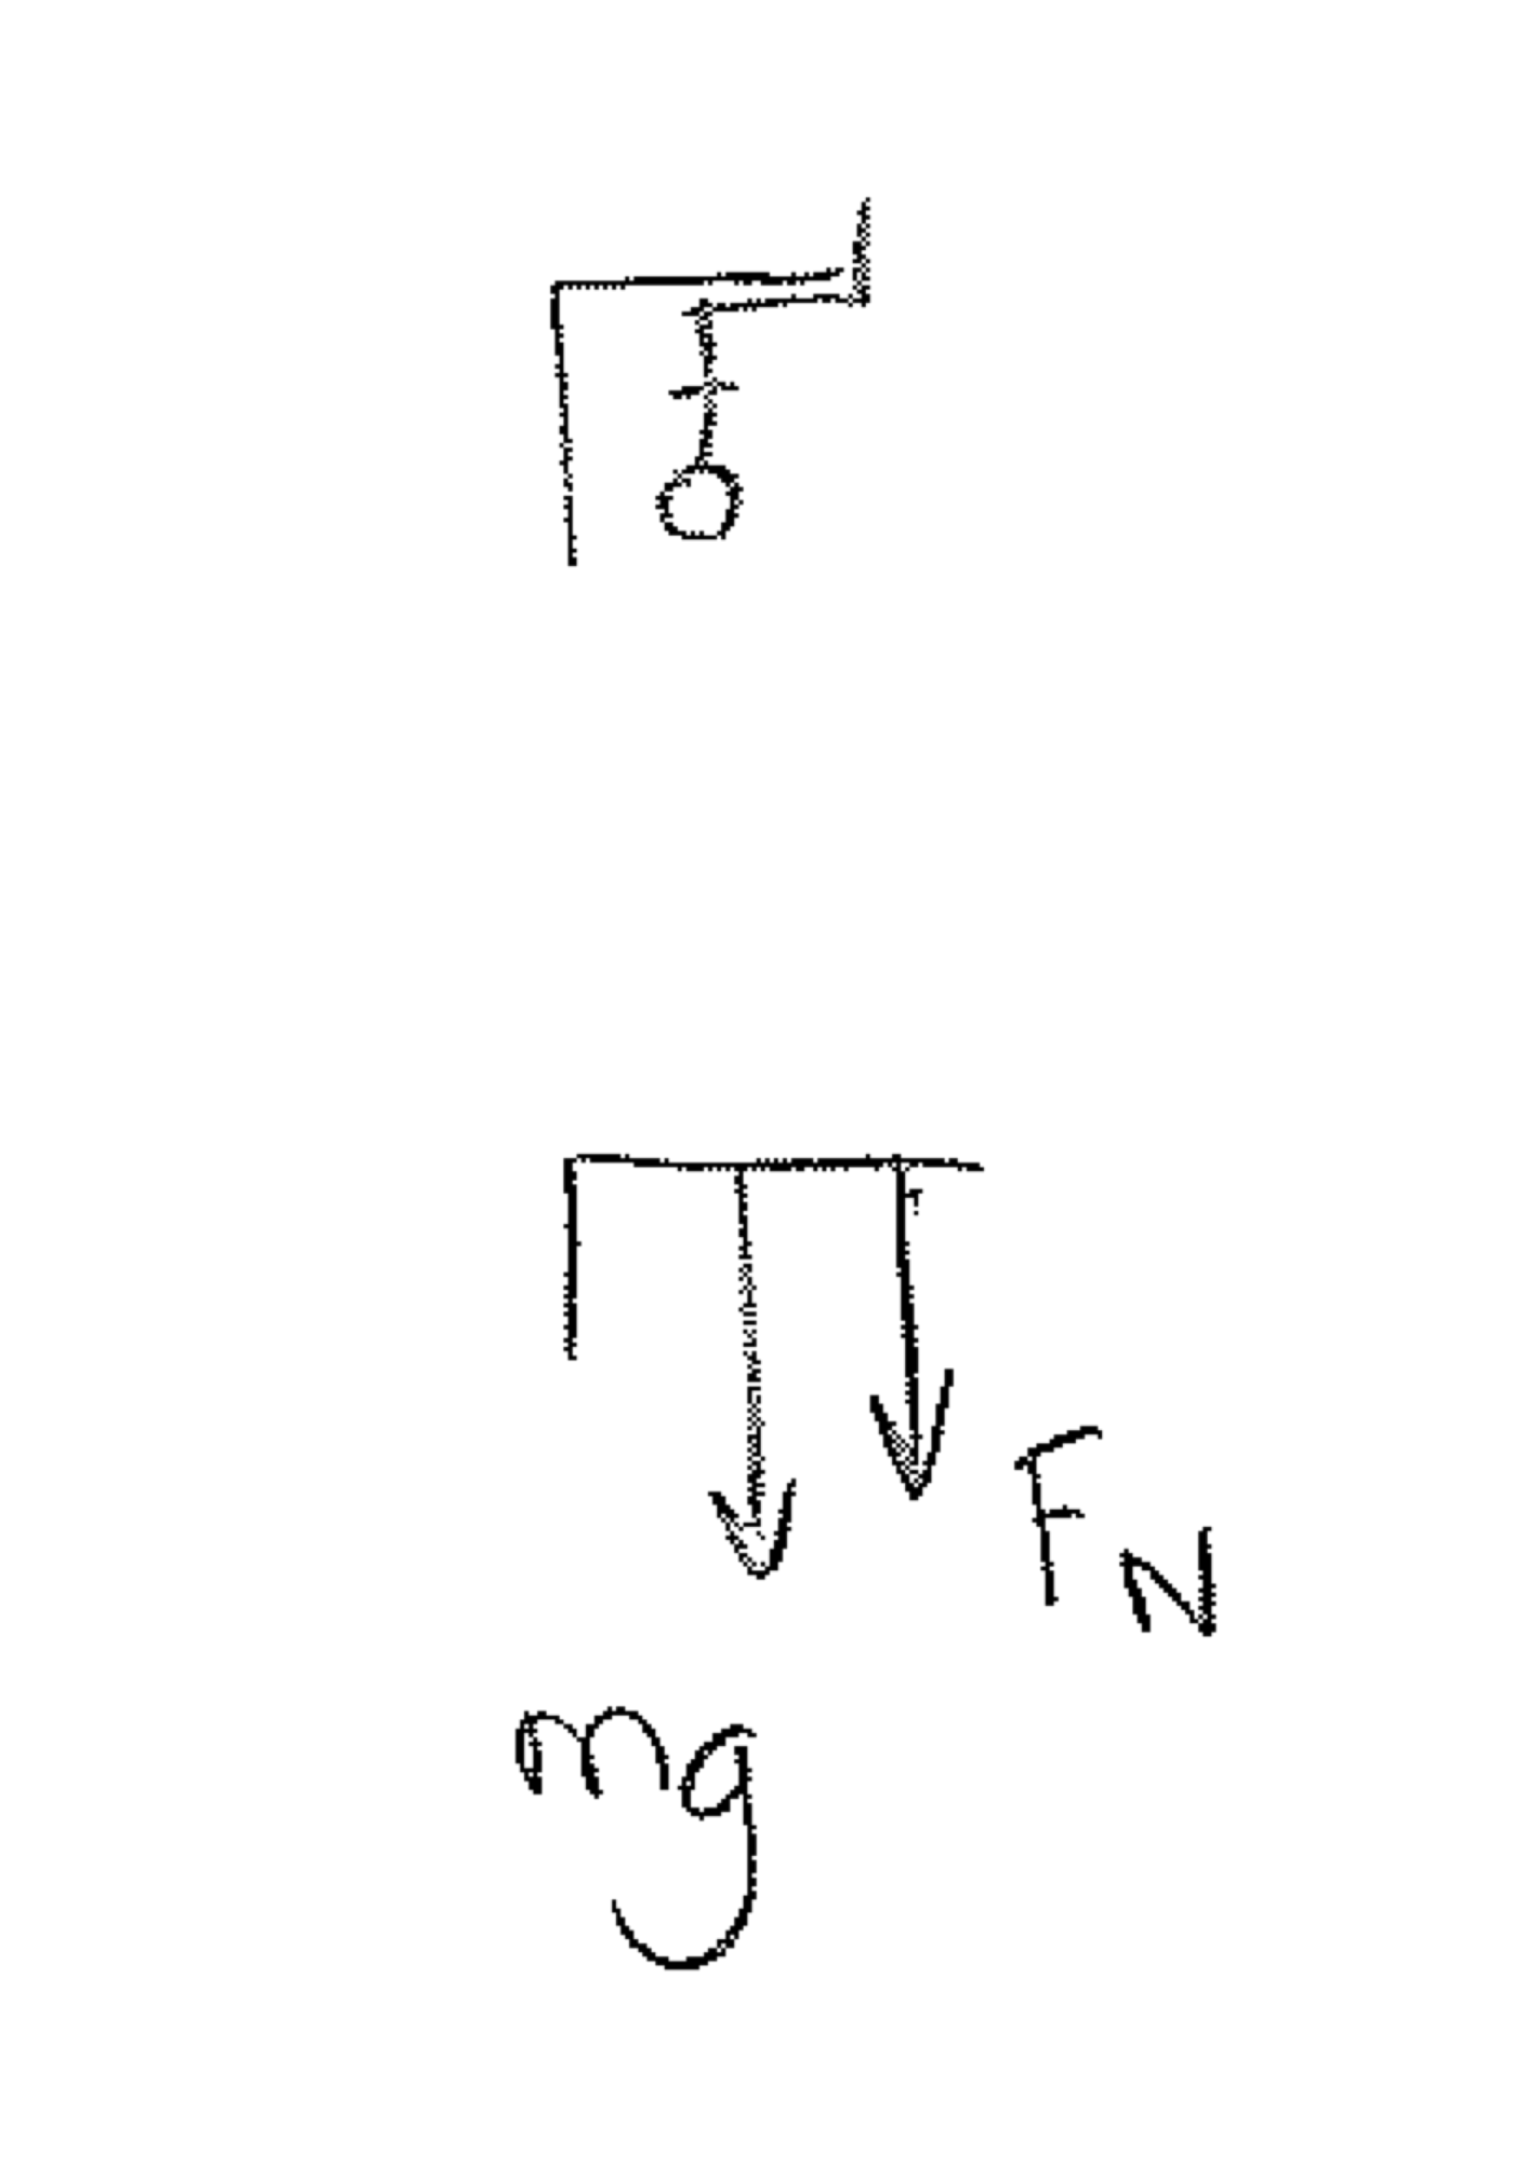



1

1

1

(c) At what speed would the Reef Diver need to travel at for the riders to experience ‘weightlessness’ at the top?

(3 marks)



0.5

1

0.5

1

(d) Explain why the rider would feel weightless, when travelling at the speed calculated in (c).

(3 marks)

* The rider and the seat are both accelerating towards the Earth at the same rate.
* This means the rider and the seat are never in contact.
* There is no normal force acting on the rider and as what we consider to be our weight is the normal force (which is zero) the rider ‘feels’ weightless.

**Question 2 (16 marks)**

The emission spectrum of a gas has eight bright lines in the visible region, as shown in the figure below.

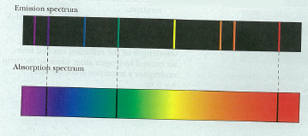

(a) Explain why there is not a corresponding absorption line for all of the emission lines.

(3 marks)

* The cold atom can only absorb photons that have the exact same energy as the difference between energy levels and the ground state.
* Atoms in excited states, however, can decay through one jump or a through a number of cascading steps.
* Thus there will be emission lines present that cannot be absorption lines as they are not transitions between the ground level and another level.

An electron energy level diagram for a hypothetical atom is shown below. Assume the atom cannot decay from the ionisation level.

0.00 eV

-0.20 eV

-0.45 eV

-0.80 eV

-1.33 eV

-3.24 eV

(b) How many emission lines (of any spectral region) could be identified for this atom?

(1 mark)

10 lines

(c) If a photon of energy 3.86 eV was incident on this atom, what would be the outcome for an electron in the ground state?

(2 marks)

* The electron would be ionized.
* And leave the atom with kinetic energy (of 3.86-3.24 = 0.620 eV)

(d) Determine the longest wavelength photon emitted by this atom and state between which energy levels this transition occurs.

(4 marks)

1

* n = 5 and n = 4

1



1

1

Laundry detergents often contain ‘brighteners’, chemical compounds that are designed to absorb ultraviolet radiation in daylight and to make ‘whites look whiter’.

(e) Which transition (singular) of this atom would be **most likely** to be in the ultraviolet part of the spectrum?

(1 mark)

* n = 5 to n = 1

(f) Name this phenomenon and explain, with reference to an appropriate diagram, how it makes ‘whites look whiter’.

(5 marks)

* Fluorescence
* The atoms absorb high energy ultraviolet light and are excited to a high level.
* The atom can then decay through a series of transitions emitting photons of lower energy
* These lower energy photons are more likely to have wavelengths in the visible part of the spectrum (forming together, white light)

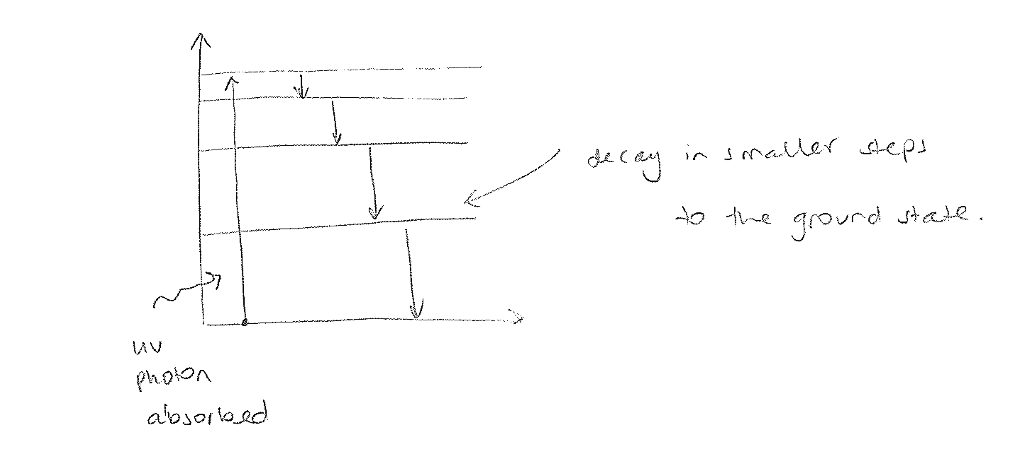

**Question 3 (15 marks)**

A DC motor, as shown in the diagram below, has an internal resistance of 3.60 Ω. When running at maximum speed on a 240 V line, the emf across the rotor is 105 V.

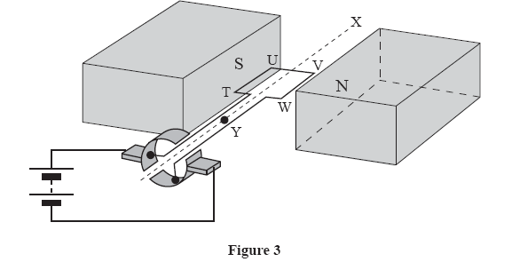

(a) In which direction will the motor rotate?

(1 mark)

Clockwise

(b) Determine the current drawn by the motor from the 240 V line when the motor first starts turning.

(3 marks)

1

1



1

(c) What is the mechanical power developed by the motor when running at maximum speed?

(4 marks)

1



or P = VI using V = 105 V and I = 29.2 A

1

1

(d) Explain why the applied emf and emf across the rotor are different.

(5 marks)

* As the motor is turning, there is a changing magnetic flux through the coil
* A changing magnetic flux will induce an emf proportional to the rate of change of flux (Faraday’s Law).
* The direction of this emf will be such as to oppose the change from occurring (Lenz’s Law).
* The induced emf will be in such a direction as to induce a current that would make the coil rotate in the opposite direction.
* Therefore the induced emf will be in the opposite direction to the applied emf and so the net emf across the rotor will be less

(εrotor = εapp - εback) .

(e) If the cells were removed from the diagram on page 25 and replaced with an ammeter and the coil was rotated manually, sketch the output you would expect to see on the ammeter.

(2 marks)

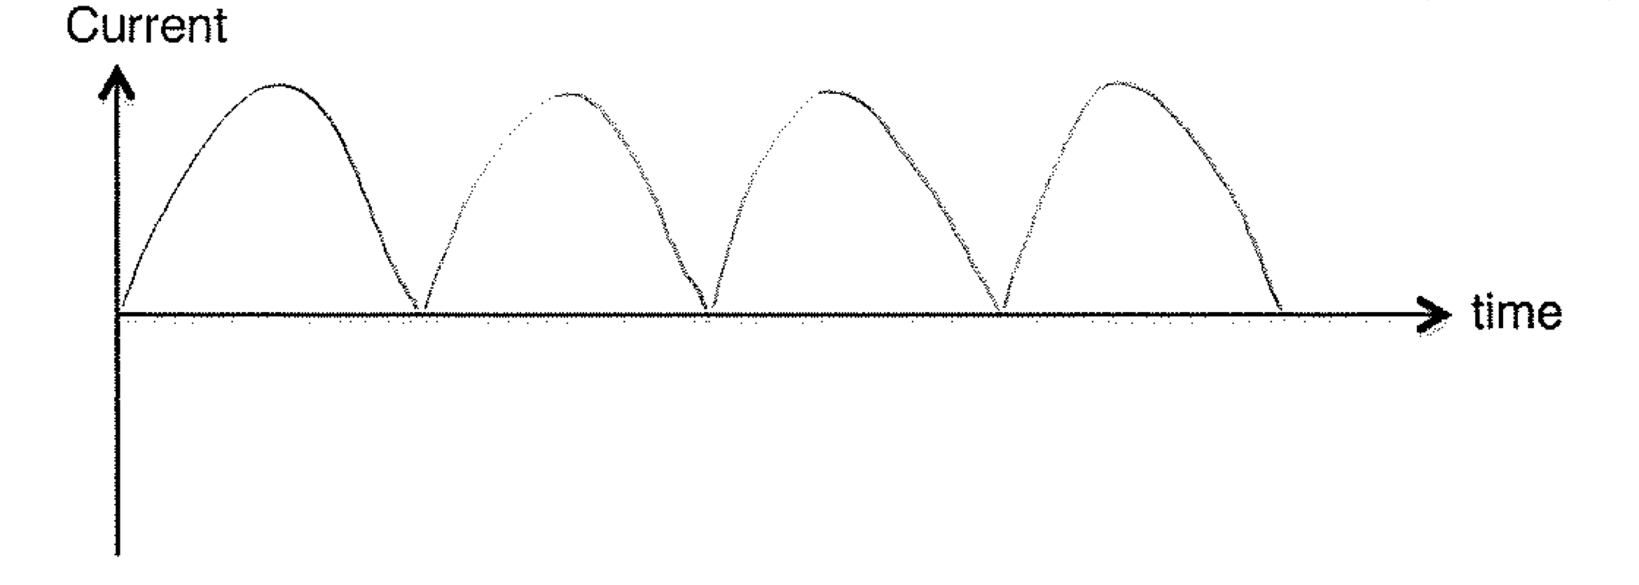

**Question 4 (16 marks)**

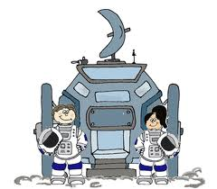

One of the problems that would face humans if we were to live in space stations orbiting planets in outer space is that we would constantly be in a state of ‘apparent weightlessness’. This can lead to osteoporosis, severe loss of muscle tone, the pooling of blood in the thorax and other undesirable physiological effects.

One proposed solution for this problem is to produce a space station that spins about its centre, as shown in the diagram below, at a constant rate. This creates artificial gravity and the humans would feel as if they are being pushed to the outside of the space station – which would then feel like ‘down’.

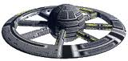

If a space station is to be a waiting area for travellers going to Mars, it would be desirable to simulate the acceleration due to gravity on the Martian surface.

(a) If Mars has a radius of 3400 km and a mass of 6.42 x 1023 kg, what is the magnitude of the acceleration due to gravity on the surface of Mars?

(3 marks)

1



1

1

(b) How many revolutions per minute would the space station of diameter 800 m need to rotate at to produce this level of artificial gravity?

(5 marks)



0.5

0.5

1

1

1

1

A Mars day is 2.70% longer than an Earth day.

(c) If the space station is to be put into a geo-synchronous circular orbit around the Martian equator, find the radius of the orbit and the altitude of the space station above Mars.

(6 marks)

1



0.5

0.5

1

1

1

1

(d) Why would it be advantageous to place the space station into a geo-synchronous orbit if the astronauts are establishing a base station on the planet?

(2 marks)

* The space station would always be above the base
* (1 of – or any other appropriate answer) Reducing fuel costs for transport (shortest distance) and making communications easier (do not have to track the space station).

**Question 5 (11 marks)**

Stars can move through space in any direction. The **space velocity** of a star describes how fast and in what direction it is moving and determining them is essential for understanding the structure of our galaxy. As the diagram below shows, a star’s space velocity *v* can be broken into components parallel and perpendicular to our line of sight.

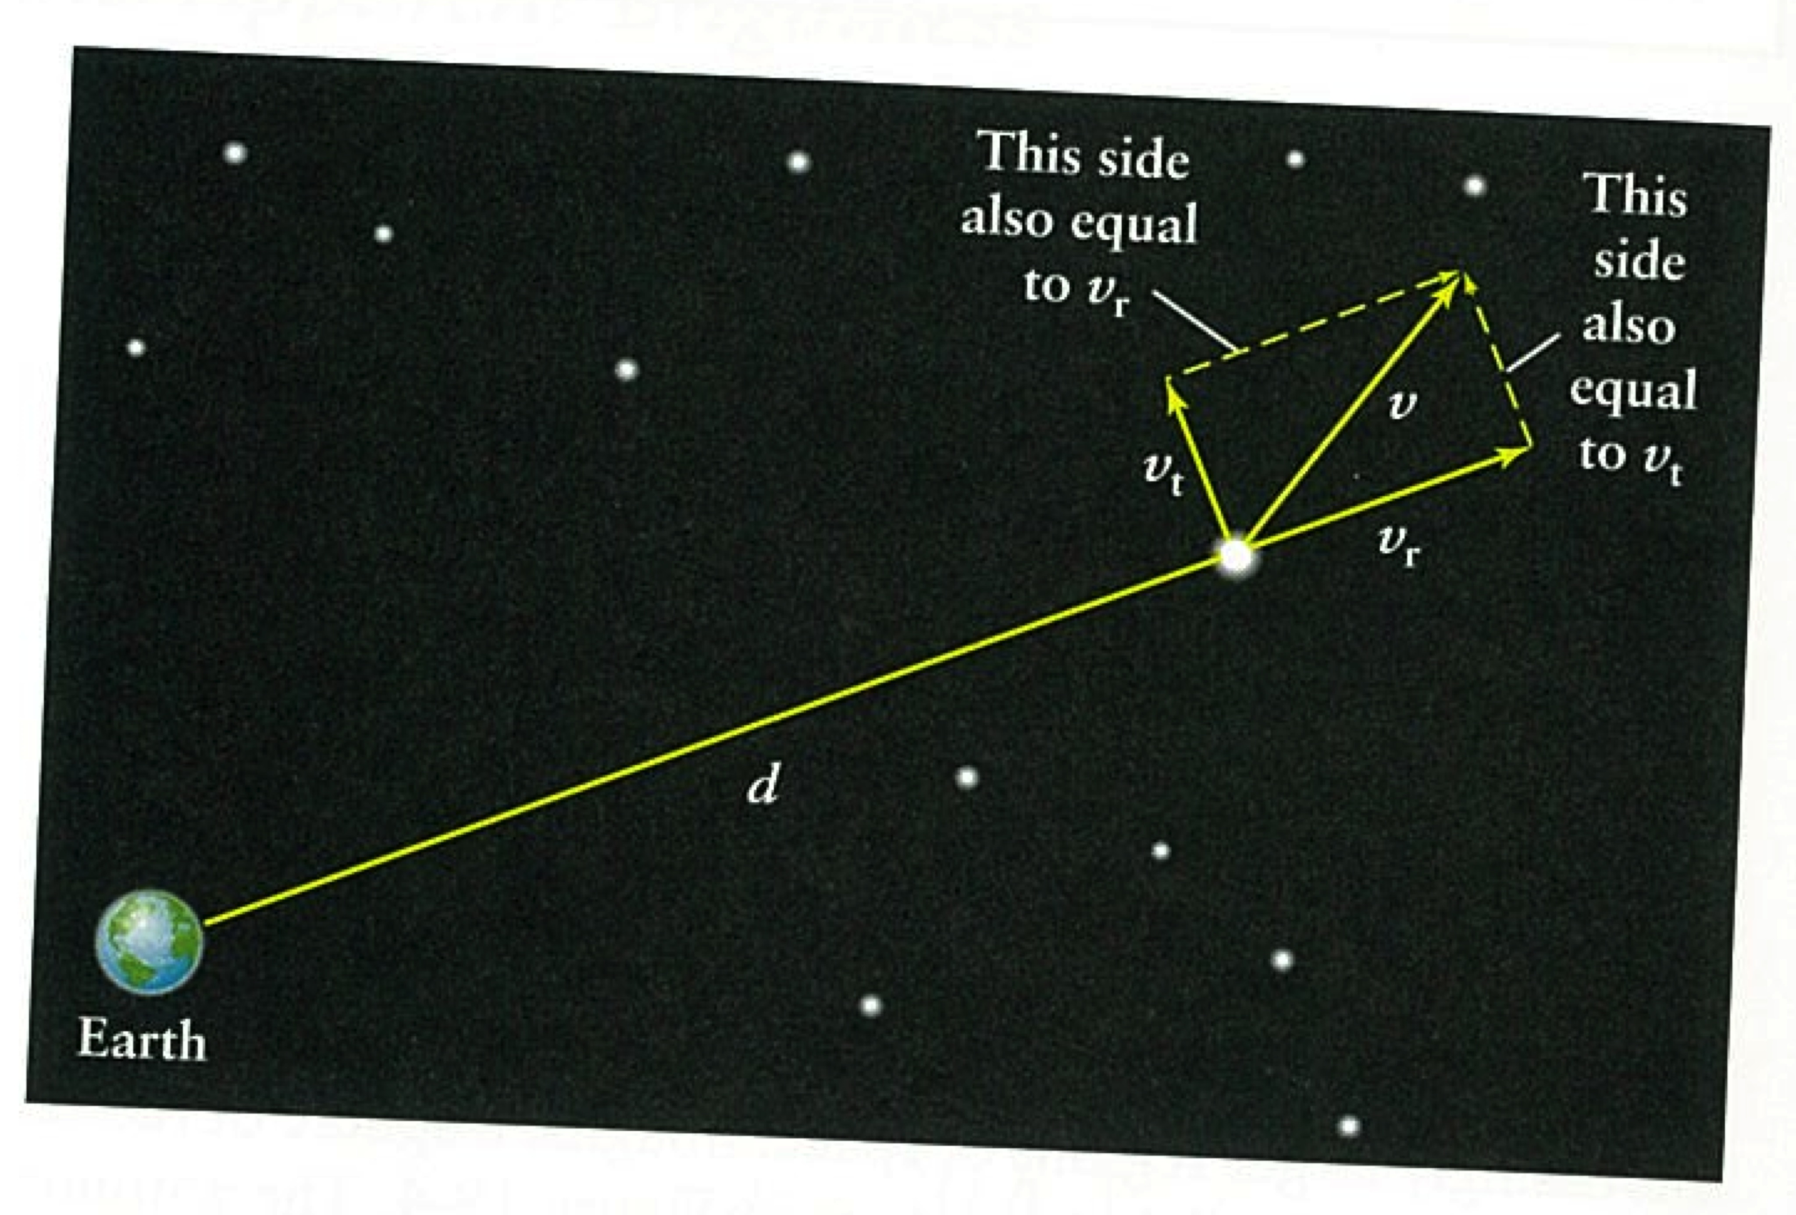

The component perpendicular to our line of sight (across the plane of the sky) is called the star’s tangential velocity (*vt*).To determine it, astronomers must know the distance to a star (d) and its proper motion (μ), which is the number of arcseconds that the star appears to move per year across the sky.

In terms of a star’s distance (measured in parsecs) and proper motion (measured in arcseconds), its tangential velocity (in km/s) is given by;



(a) Barnard’s star has a proper motion of 10.4 arcseconds per year and is at a distance of 1.82 pc from Earth. Determine the tangential velocity of Barnard’s star.

(2 marks)



1

1

The component of the star’s motion parallel to our line of sight – either directly towards us or directly away from us, is called its radial velocity (*vr*). The radial velocity of a star can be measured from the Doppler shifts of the star’s spectral lines.



Where λ0 is the wavelength of a spectral line measured in the laboratory on Earth.

A particular spectral line of iron in the spectrum of Barnard’s star has a wavelength of 516.438 nm. When measured in the laboratory on Earth, the same spectral line has a wavelength of 516.629 nm

(b) Is this line blueshifted or redshifted?

(1 mark)

* blueshifted

(c) Would this mean the star is moving towards us or away from us? Explain your answer making reference to the Doppler effect.

(4 marks)

* The star is moving towards us.
* If an object is moving towards us, each time the source moves closer, it moves closer to the previous wavefront it emitted.
* As the distance between consecutive wave fronts is smaller the light is blueshifted.

Could also include an appropriate diagram for 1 mark.

(d) Determine the magnitude of the radial velocity of Barnard’s star.

(2 marks)



1

1

(e) Calculate the space velocity of Barnard’s star.

(2 marks)

1



1

**Question 6 (18 marks)**

The diagram below shows two ways in which a wave can travel along a slinky spring.



λ

(a) State and explain which wave is longitudinal.

(2 marks)

* Wave B is longitudinal
* The particles undergo motion parallel to the motion of the wavefront.

(b) On the diagram:

(3 marks)

i. clearly indicate and label the wavelength of wave B

(between any two identical points on the diagram)

ii. use arrows to show the direction in which the points P and Q are about to move as each wave moves to the right.

A laboratory experiment is set up to measure the speed of sound in air. A speaker emitting a frequency of 495 Hz is placed over the top of a container filled with water. Water is drained gradually from the bottom of the container and the length of air in the tube is recorded when a resonance is heard.

Air

Water

The first three resonances are recorded when the length of air in the tube is equal to 0.166 m, 0.500 m and 0.834 m.

(c) Sketch the standing wave patterns for the first three harmonics excited. Assume the container was completely full at the beginning of the experiment.

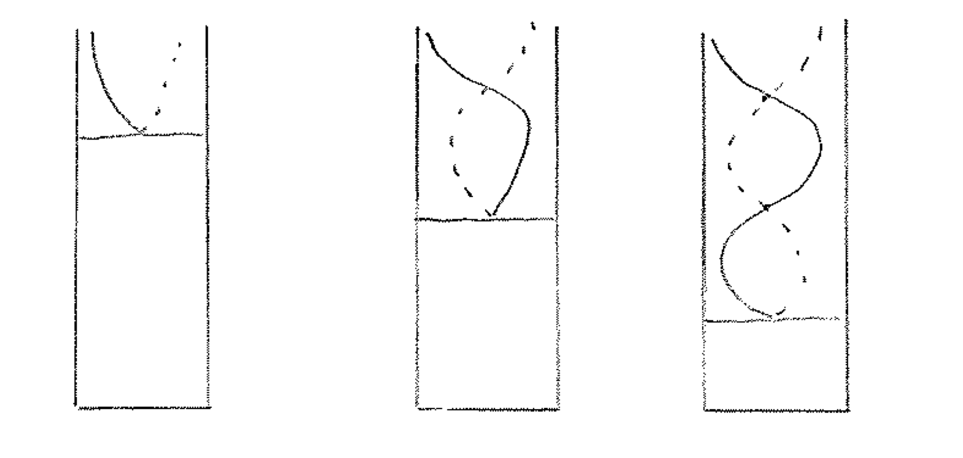(3 marks)

(d) Determine the speed of sound in air and the end error in the pipe from the experimental results.

(4 marks)



0.5



0.5

0.5



1

0.5

0.5

0.5

(e) Calculate the location of the next resonance (assume the tube is sufficiently long and ignore end error).

(2 marks)



0.5

0.5

1

(f) If a tone of higher frequency were used, would the resonances be closer together or further apart? Explain your reasoning fully.

(4 marks)

* As the speed of sound in air will not change
* v = fλ, so as the frequency increases, the wavelength must decrease to keep the product of wavelength and frequency equal to the same value.
* If the wavelength decreases, the length of each resonance (the position of each resonance) = nλ/4 will decrease.
* Therefore the resonances will be closer together.

**End of Section Two**

YEAR 12

PHYSICS STAGE 3

**TRIAL EXAMINATION 2012**

**Section Three: Comprehension**

This section has **two (2)** questions. Answer **all** questions. Write your answers in the space provided.

Suggested working time for this section is **40 minutes**.

NAME:_______________________________________

**Question 1 (15 marks)**

Adapted from the article

Gallery of Whispers by Oliver Wright

(Physics World, Volume 25 No 2 February 2012)

A whispering gallery is a circular, hemispherical or elliptical or enclosure, often beneath a dome. When standing within it - when one person whispers into the wall at one side - the whispers can be heard clearly by others standing in other parts of the gallery. One very famous whispering gallery is found at St Paul’s Cathedral in London (see Figure 1). Closer to home there is a whispering wall at the Kings Park War Memorial (see Figure 2).

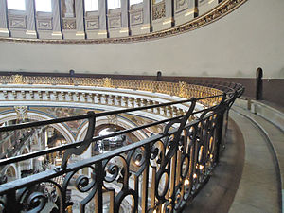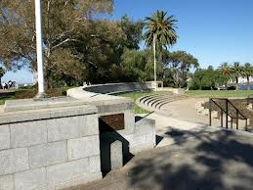

Figure 2 – Whispering wall at

Kings Park War Memorial.

Figure 1 – Whispering gallery

at St Paul’s Cathedral.

The reason for these whispers was – and often still is – assumed to be a focusing effect whereby the dome reflects the sound waves to a focus on the completely opposite side to where the whisper was made. This explanation, however, is flawed because the whisper can be heard at any point around the whole circumference of the gallery, not just at the opposite point.

Lord Rayleigh (a famous physicist and nobel laureate), used a whistle to create sound and flame to remotely detect these sound waves via its visible flickering. Rayleigh’s findings led him to create a new model that still holds today. The so-called whispering gallery waves responsible have since been found throughout physics - they can surf on the nucleus of an atom, light up a glass bead or skim on a star. They have also been used to detect imperfections in curved surfaces, allowing engineers to detect a cracked pipe or researchers to detect molecules of potentially explosive hydrogen on the surface of a tiny crystal ball.

Rayleigh surmised that sound waves produced close to the gallery wall travel while clinging to the wall – that they ‘creep around the gallery’, as he phrased it. The sound waves can be imagined to bounce around the wall, making a path that looks like a polygon sitting inside the circular gallery.

Fitting sound waves into a confined space, whether a cathedral or a ball, brings resonance into play. Wave interference dictates that only certain pitches, or frequencies, of sound can exist. Just like the strings of a guitar or the energies of electron waves around at atom, the pitch is quantised and the sound forms patterns called modes.

(a) Explain what is meant by the term **resonance** and give an example of when resonance occurs (different to the ones given in the text).

(4 marks)

* Resonance is when an object is forced to oscillate by an outside source
* At a frequency that is the same as or close to one of its natural frequencies.
* When this occurs, the amplitude of the oscillations of the object will increase significantly.
* Any suitable example of resonance – e.g. tuning forks, stereo making objects vibrate  **not** Tahoma Narrows.

(b) Explain what is meant by the term ‘quantised’.

(1 mark)

* Can only occur at discrete (not continuous) values.

Whispering-gallery modes are waves that follow a concave surface; they are guided by the wall curvature and do not exist at a straight wall. Rubbing a wetted finger around a good quality wine glass will produce a vibrational pattern formed by waves analogous to whispering-gallery waves travelling in both directions around the rim and obeying the same wave physics as resonance. The vibration fits exactly two wavelengths around the circumference, as shown in Figure 3.

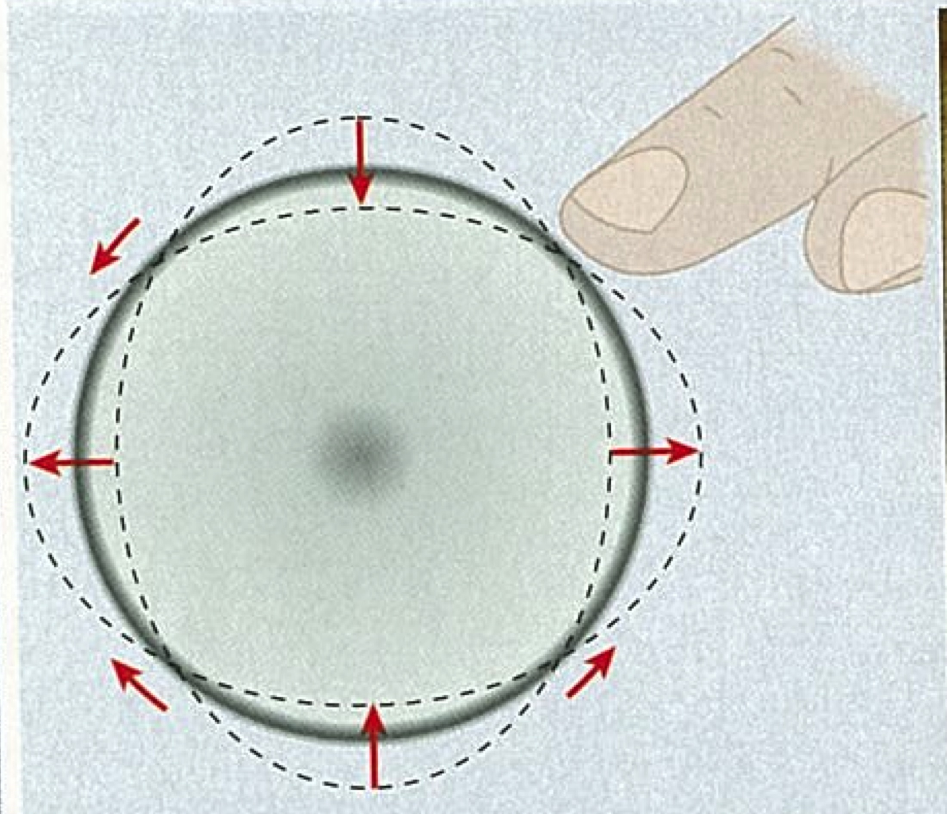

Figure 3 – the vibration on the rim of a wine glass

Points near the maxima and minima in the vibrational pattern move in radial directions, whereas the points halfway between move in tangential directions. The whole pattern is dragged around with your finger.

(c) Look carefully at Figure 3 and state what is meant by ‘vibration in the radial’ direction and ‘vibration in the tangential’ direction with reference to the surface of the glass.

(2 marks)

* Vibration in the radial direction moves inwards and outwards from (perpendicular to) the side of the glass.
* Vibration in the tangential direction is parallel to the side of the glass (in the same direction as the finger is moving).

(d) Estimate the wavelength of the resonance set up around a regular wine glass (wine glasses usually have slightly larger diameter than a regular drinking glass).

(2 marks)

Radius of wine glass: 3 cm to 5cm = 0.5 mark. Any other values 0.

0.5



0.5

0.5

(e) Determine the frequency of the resonance heard for your wine glass in (d) on a 25.0**°**C day. If you could not calculate a value for (d) use 0.20 m

(3 marks)

1



1

1

As the value being used was estimated – answer should still be to 2 sf.

(f) What effect would having water in the glass have on the pitch of the sound heard? Explain your reasoning.

(3 marks)

* The pitch of the sound would decrease.
* The liquid in the glass increases the mass of the system.
* Greater inertia means the glass vibrates slower and so the frequency of the sound would decrease.

**Question 2 (21 marks)**

A ship uses a sonar system, emitting waves at a frequency of 262 Hz, to determine the bulk modulus of water. The system emits underwater sound waves and measures the time interval for the reflected wave (echo) to return from set distances to the detector.

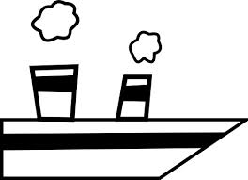

The velocity of sound in a substance is related to the bulk modulus (a measure of how a substance responds to a change in volume) by;



Where: v is the velocity of sound in a substance

B is the bulk modulus of the substance

ρ is the density of the substance (units: kgm-3)

The (one-way) time intervals for (one-way) distances are given in the table below.

|  |  |
| --- | --- |
| t( x 10-1 s)  ± 0.05 x 10-1 s | Distance (x 102 m)  ± 0.10 x 102 m |
| 1.35 | 2.00 |
| 1.69 | 2.50 |
| 2.03 | 3.00 |
| 1.51 | 3.50 |
| 2.71 | 4.00 |
| 3.38 | 5.00 |

(a) Using the data above, what graph would you plot to obtain a straight line graph, the gradient of which is the velocity of the sound waves in water.

(1 mark)

distance vs time

(b) Plot your graph with appropriate error bars and **lines** of best fit.

(7 marks)

1 – Title 2 – Lines of best fit

1 – Axis labels and units 1 - Linear Scale

1 – error bars (horizontal and vertical) 1 – correct data points

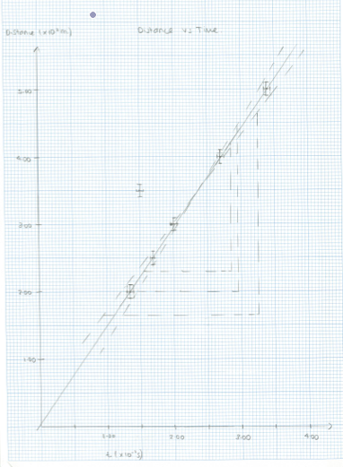

(c) Determine the gradient of your graph including an appropriate estimation of error.

1

(7 marks)



0.5

1

0.5

1

0.5

1

0.5

Error = (1630 – 1300)/2 = 170

1

or could work out error using fractional uncertainty and the given values.

1

1.46 ± 0.17 (x 103 ms-1)

-0.5 mark if not written specifically to 3 sf. -0.5 mark if error written incorrectly.

(d) Given that the density of water is 1.00 x 103 kgm-3, determine the bulk modulus of the water.

(3 marks)



1

1

1

(e) What is the smallest size of deflector pad that could be used with the frequency of the system?

(3 marks)

1

1



1

**End of Section Three**